**Data Professional Survey Dashboard**

## **Project Overview:**

This comprehensive dashboard aims to provide insightful visualizations and analysis of the survey data collected from data professionals.

The Data Professional Survey Breakdown dashboard is designed to assist in understanding the preferences, trends, and challenges data professionals face. It offers a user-friendly interface with interactive visualizations to facilitate data exploration and decision-making.

### **Dashboard Overview and Requirements:**

1. **Country Distribution**: The dashboard visually represents the countries where the survey was taken. It helps understand the geographical distribution of survey participants and identifies regions with significant data professional presence.
2. **Average Salary by Job Title**: This section provides an overview of the average salary based on different job titles. It allows for comparisons between job roles and helps identify positions with higher wages within the data professional community.
3. **Total Count of Survey Takers**: The dashboard features a visualization that showcases the total count of survey takers. This metric provides an understanding of the sample size and the extent of the survey's reach within the data professional population.
4. **Average Age of Survey Takers**: In this section, the dashboard presents the average age of the survey takers. It offers insights into the age distribution of data professionals and helps identify age-related trends or preferences.
5. **Average Rating of Survey Takers' Happiness:** The dashboard includes a rating scale from 0 to 10, where survey takers rate their happiness level. The average happiness rating provides an overall understanding of job satisfaction within the data professional community.
6. **Favorite Programming Languages**: This section highlights the favorite programming languages chosen by survey takers. The visualization helps identify the most popular languages among data professionals, enabling organizations to align their technology stacks accordingly.
7. **Difficulty in Breaking into Data:** The dashboard analyzes the perceived problem in breaking into the data field. The options provided include "neither easy nor difficult," "difficult," "easy," "very difficult," and "very easy." This information helps understand the challenges aspiring data professionals face and provides insights into the barriers to entry.
8. **Average Happiness with Salary:** The dashboard presents a rating scale from 0 to 10, where survey takers rate their happiness with their current salary. The average rating helps assess the satisfaction level of data professionals regarding their compensation.

### **Findings:**

The survey received responses from data professionals across various countries, providing a global perspective where a maximum number of respondents are from United States.

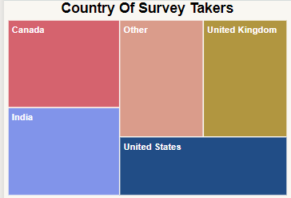

Job titles such as Data Scientist and Data Engineer tend to have higher average salaries than other roles.

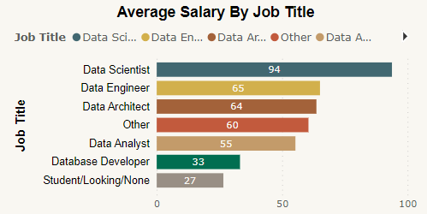

The total count of survey takers indicates a significant sample size, enhancing the statistical validity of the findings. There are 630 Survey respondents.

The average age of survey takers is 29.87 years, reflecting the age demographics of the data professional community.

The average happiness rating showcases the overall job satisfaction levels among the survey participants.

‘Python’ and ‘R’ are among the most popular programming languages, indicating their popularity in the data professional field.

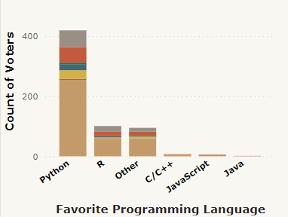

Breaking into the data industry is perceived to be moderately difficult by most survey takers. The average happiness rating with salary provides insights into how satisfied data professionals are with their compensation. In particular, the average happiness with salary among the survey participants is 4.27, indicating a moderate level of satisfaction. Additionally, the average happiness with work/life balance is 5.74, suggesting a relatively higher level of satisfaction with the balance between work and personal life.

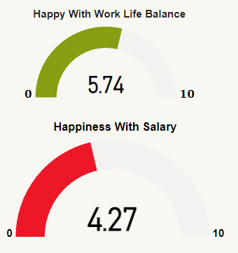

The average salary is almost equal for both the genders (Female & Male), were Female gets 55.2K and Male gets 53.5K

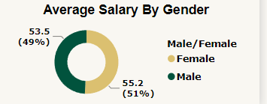

## **Tools Used:**

1. Microsoft Excel  
2. Power BI Desktop

**Visualization Used:**  
1. Treemap  
2. Stacked Column Chart  
3. Donut Chart  
4. Pie Chart  
5. Card   
6. Stacked Bar Chart  
7. Gauge

## **Outro:**

In this Dashboard and Project, we have analyzed survey data from data professionals to uncover valuable insights about the industry. These findings shed light on the satisfaction levels of data professionals with their compensation and work-life balance. One of the most interesting aspects was the favorite programming languages among data professionals, with Python and R being the top choices

## **Final Dashboard:**

All the graphs generated are interactive.

